

National Textile University
Department of Computer Science
Subject: Mobile Application Development

Submitted to: Sir Rehan

Submitted by: Ayema

Reg. number: 23-NTU-CS-1142

Lab:7

Semester:6th

Task 1
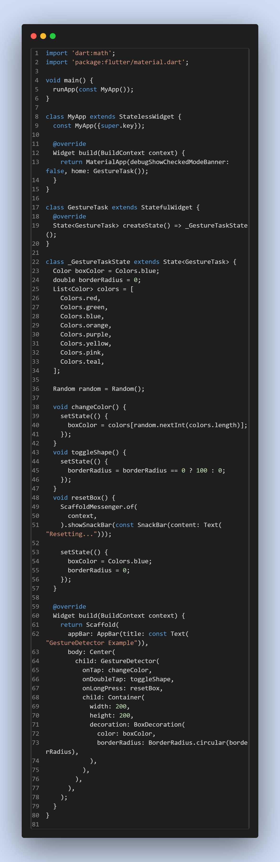

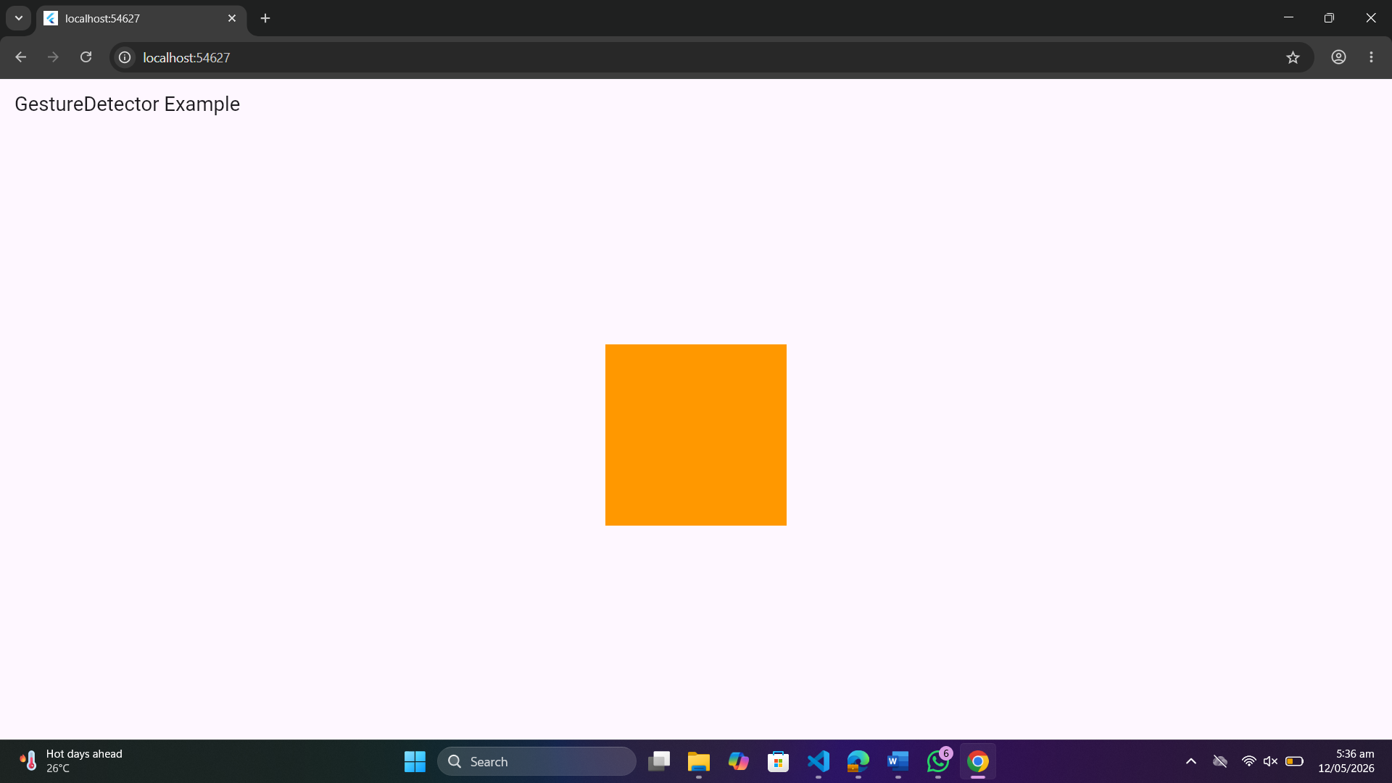

Task 2
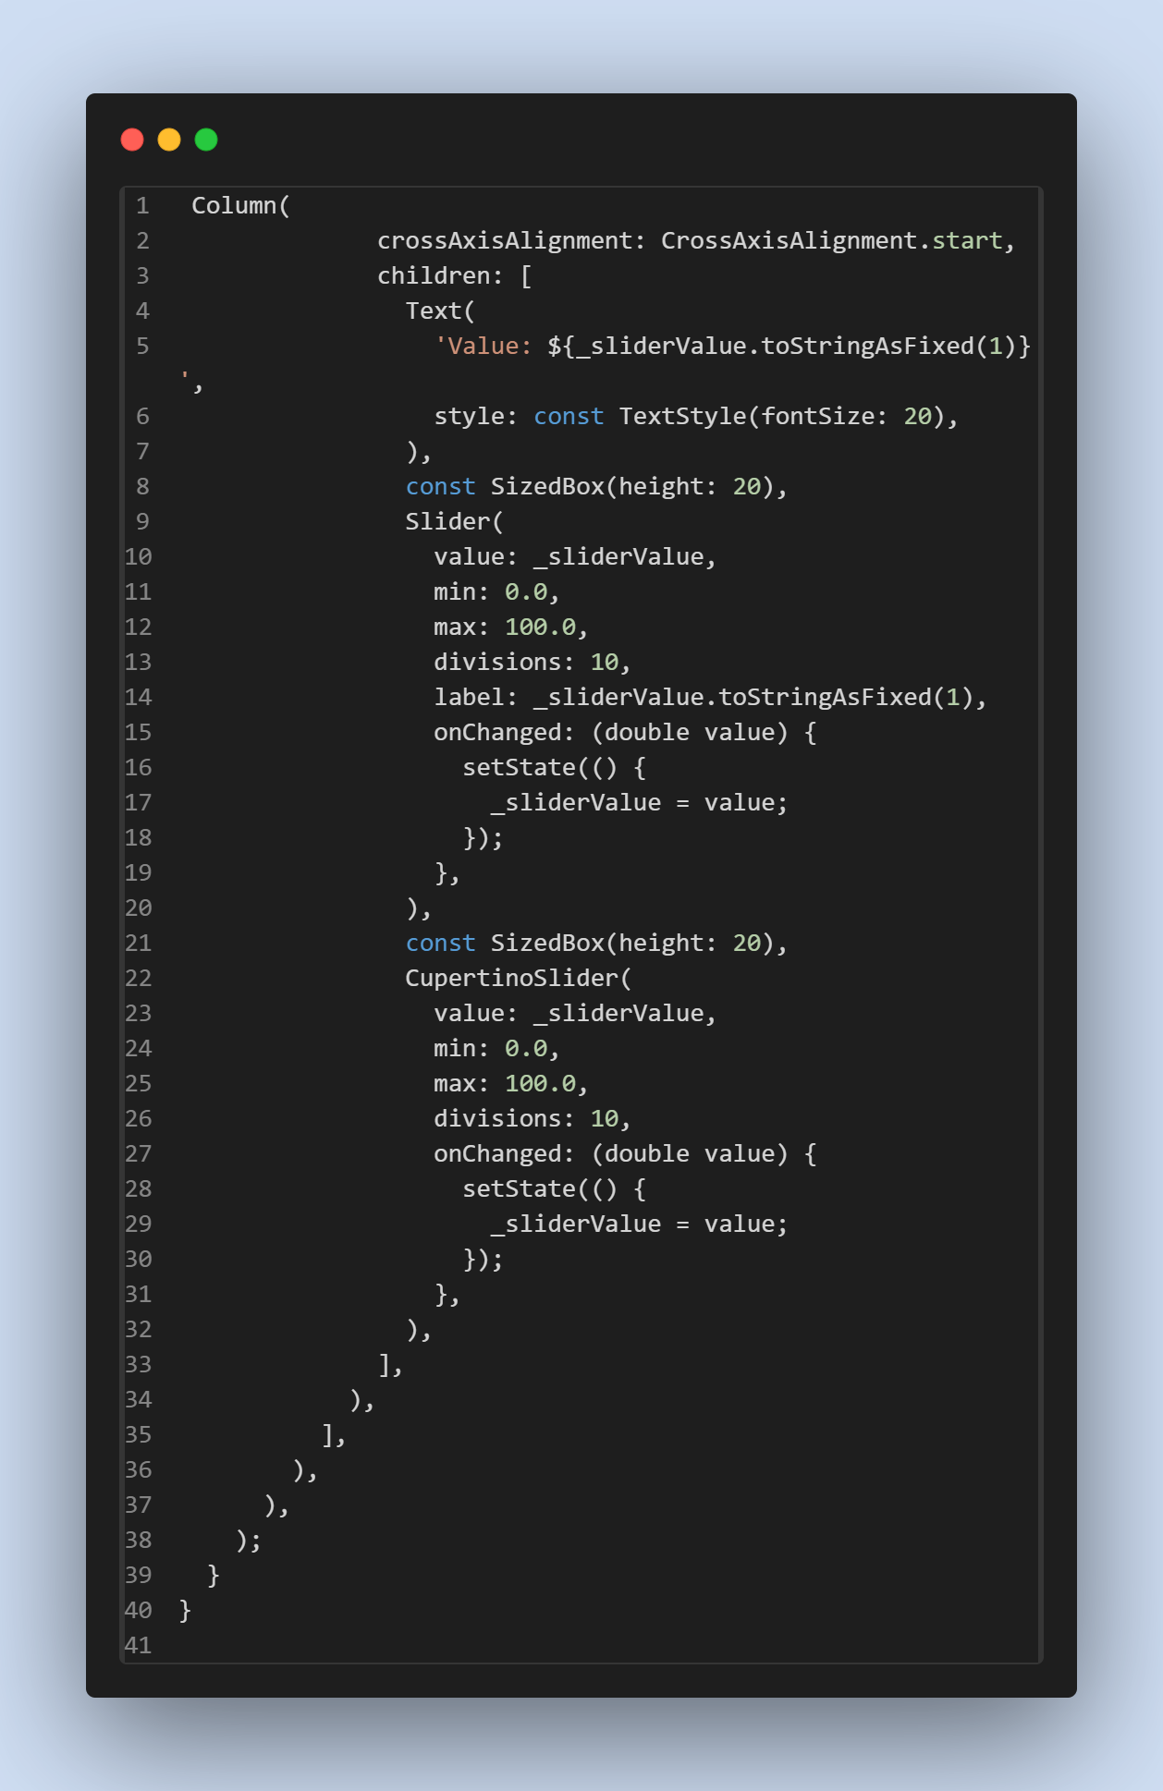
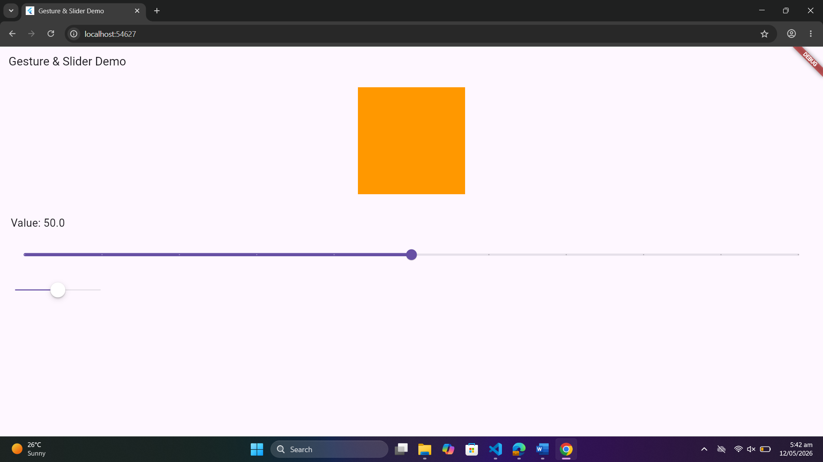

Task 3
